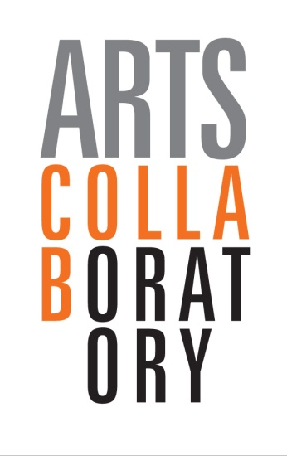

ARTS COLLABORATORY

Call for Proposals

Long term support for independent visual arts organizations focusing on collaborative art practices and social innovation

Grant Application Formto be filled out in English, French or Spanish

Deadline for submission of summary proposal
April 15, 2013

Concept note

I. APPLICANT

Application form:  Arts Collaboratory | telephone number  for info: 0703765611  Mail your application form to:  call@artscollaboratory.org

This application form is the basis for your application to Arts Collaboratory. Keep it short and to the point, and limit yourself to maximum 6 A4 pages.

1. General details of organisation

Name of organization (lead of administration)
In case of coalition: name of second and third participating organisations
title of programme
Name of contact person
Correspondence address
Postcode
Place of business/country
Telephone number
E-mail address
Website
Legal form of organisation(s) applying for funding
year of foundation of organisation(s)
number of employees (m/f)
Location(s) of the action: - specify country(ies), region(s) that will benefit from the action
Total duration of the action (maximum 28 months):
Total amount in (Euro) of the programme:
Amount (in Euro) of requested Arts Collaboratory contribution:
How are you related to Arts Collaboratory, how did you hear about AC

II. THE PROGRAMME

The applicant must ensure that the text of the Summary:

- does not exceed 6full pages (A4 size);
- responds, in the same sequence, to the headings listed below. It is expected that the size of each section will reflect the relative importance of each

1. Background/Rationale of programme
a) Describe the background/motivation for the initiative. Include an analysis of the general and cultural context in your country or region. Describe the role and contribution of your organisation to the problems described in the analysis.
b. Describe the relevance of your programme to the specific objectives of the call for proposals: how will your programme contribute to the objectives of improvement of artistic quality and stimulating socialinnovation?

2. Initiator:
a. What are the mission, (artistic) vision and goals of your organisation (in case of coalition: describe for each of participating organisations and for the overall programme)
b) Give a concise description of your organization (organisational structure, how is supervision and governance organized, number of persons (paid and unpaid) active in the organisation).
3.Collaborations, participants and target groups
a) Describe in short how your organisation is connected to other players in the field (cultural and non-cultural organisations and individuals); describe the main connections and collaborations that help you to achieve your aims, and the way you co-operate.
b). How does your organisation support, connect with and/or empower other organisations, groups and individuals (in and outside artworld) in your environment.
c). List the main participants, target groups and other beneficiaries (include numbers) in your activities and the way you involve them in your activities.
4. Activities
Describe how you aim to achieve your goal. Describe the initiative, including the activities. (per objective or programme, in summary)

5. Results and reach
a) What changes do you believe this initiative can bring about with regard to the theme?
b) What are the expected (qualitative and quantitative) results?

- Qualitative Results expected: specify per objective/programme
- Quantitative results expected: specify per objective/programme
6.Besides a funding programme Arts Collaboratory is a platform for exchange and knowledge sharing on strategies and content with regards to arts and social innovation in Africa, Asia and Latin-America
a. What could your organisation contribute to other partners and their networks in Arts Collaboratory, or to the platform as a whole
b. Provide ideas how you could connect knowledge, contacts and/or networks in your environment to the global arts collaboratory platform.
7. time scale
Please include a time scale for the programme and its main components
8. Brief budget and financing scheme
Provide a summary of the budget and indicate its expected financing.Please
- include a clear funding plan: include your own contribution, the amount requested of Arts Collaboratory and the contributions of other donors, sponsors or any other income. The budget should be fully covered
- include costs of external financial audit reports (1x year)
- make sure that the budget corresponds with the programmes/objectives and activities

Criteria Arts Collaboratory Call:Long term support for independent visual arts organizations focusing on collaborative art practices and social innovation

Remarks:
- every of the below criteria is considered in relation to the specific context the organization is working in.
- these criteria are programme specific and will be used next to standard assessment criteria of Hivos and DOEN with regards to governance and financial management.

Criteria:
- The organization must be based in Africa, Asia, Latin America
- The organization provides an independent platform for visual artists in its local context, and serves the needs of those in terms of training and/or research, production, platform or presentation.
- The organization promotes high quality art practice.
- The organization has a proven interest and activities in the field of social innovation
- Collaborative attitude: the organization has a wide reach in its context and a collaborative attitude towards other arts platforms, -groups or -organizations in the country/wider region and possibly towards actors in other sectors in society (in application explain both view on collaboration, existing co-operations, broad network).
- The organization has an interest in international cooperation and is willing to take up responsibility in this within the Arts Collaboratory platform. It can connect the international network to the local community and vice versa.

